|  |
| --- |
| **Zhang Xiao 188-9673-0515** |
| |  |  | | --- | --- | | Position applied: **JavaScript Engineer** |  | | Email: **xiao_leon@qq.com** | | Date of birth: 1989.09 | | Corporation: Hillstone Networks | | English proficiency: Good CET-6 (509) | | Personal blog: http://www.xiaoleon.cn |  | |
| **Education:** |
| |  |  |  |  | | --- | --- | --- | --- | | 2011.09 – 2014.03 | SouthEast University | Software Engineering | Master | | 2006.09 – 2010.06 | Wuhan University | Electronic Information Science and Technology | Bachelor | |
| **Specialised Skills** |
| |  |  | | --- | --- | | Professional | JavaScript、ExtJS、Sencha Touch、d3.js、Node.js、Cordova | | Skilled | React、Python、Scrapy、Flask、MySQL、Electron.js | | Theoretical | Front-end knowledge of Web & Http、Software engineering、UML | |
| **Jobs:** |
| |  | | --- | | **2015.11 – Now Hillstone Networks Front-end Developer**  Responsible for the framework of the cloud platform (Web & App), the prototype design of the product requirements, the code implementation of the modules, and the maintenance of the project, etc.  **2014.04 – 2015.10 Second Highway Consultants Corporation Software Engineer**  Responsible for the development of the enterprise information system by using C# and SQL Server 2012, and the maintenance of the whole system. | |
| **Project Experience:** |
| |  | | --- | | 1. **Hillstone CloudView 2015.11 – Now**   **Brief Introduction:**  A Cloud Platform reserved by Hillstone, which can manage all the customer’s firewalls in the cloud, and provide big data analysis in Internet Security and other SASS service, including Web, IOS App and Android App.  **Responsibility:**   1. Develop web application using ExtJS and RxJS framework 2. Develop IOS & Android app using SenchaTouch and Cordova framework 3. Develop graphical display application using d3.js 4. Develop related tool application using Node.js | | 1. **Hillstone HSM 2015.11 – Now**   **Brief Introduction:**  UI of Hillstone HSM hardware, which is used to centralize all the firewalls in the inner-network and provide quick configuration and deployment.  **Responsibility:**   1. Reconstruct the existing Flex HSM project using ExtJS and RxJS framework. 2. Develop new HSM functions using Flex | | 1. **Expert information mining 2016.03 – 2017.09**   **Brief Introduction:**  A project cooperating with my postgraduate supervisor in spare time. With my working experience, I help and guide the postgraduate students to accomplish their task according to the professor’s research subjects.  **Responsibility:**   1. Learn the programming method of python 2. Learn the Scrapy framework, then crawl and store the relevant literature data 3. Learn the knowledge of NLP(Natural Language Processing)， and process the crawled data, such as cleaning, segmentation, TFIDF modeling and LDA modeling. 4. Learn the Flask framework, and develop Restful interfaces to provide data 5. Guide the members to standardize their programs, and share technology with each other | | 1. **Enterprise Information System 2014.09 – 2015.04**   **Brief Introduction:**  Information development and maintenance system of CCCC Second Highway Consultants Corporation, including contract management, workflow management, financial management, subcontractor management, etc.  **Responsibility:**   1. Accomplish requirement analysis and rapid prototyping design of the project. 2. Responsible for C# code implementation and supervising the progress of the project. 3. Organize training and maintenance after the project is online. | |
| **Awards & Certificates:** |
| |  |  | | --- | --- | | **2018.01** | QCCSTP (Senior) Information System Project Manager | | **2017.10** | Government subsidy for urgently-needed professionals in Suzhou | | **2015.05** | Second prize of CCCC excellent QC teams | |
| **Self-Evaluation:** |
| |  | | --- | | 1. Great learning ability. Always ready to learn new theories (tools) needed in work, and then to solve the related problems, and make effective document records. | | 1. Good team player, can integrate the team very quickly, and create a harmonious working atmosphere. | | 1. Good will to share the technology and working content within the permitted scope, which helps enhancing myself and others’ ability. | |

最后这个自我评价部分，我建议中文也修改一下，1和3雷同，我建议你看看甲骨文公司的企业文化，找找里面的关键词，挑出一两个来，可以适当改编成自己的自我评价，放在这里。你找好了我来帮你弄最后这部分的。第一点可以不用变，就2-3点。

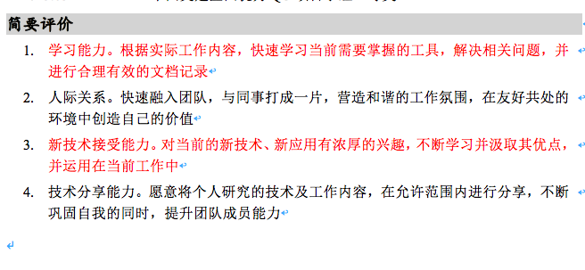

总评：1. 看中文简历的时候，感觉是：哇塞，我老公竟然这么牛！恨不得把你的简历post到网上让所有人知道我有个这么牛的老公。哈哈

2. 看英文简历第一遍的时候，哇塞，我老公英文也这么厉害，他弄到这么晚，肯定是不想让我花太多时间帮他查找翻译吧，所以自己查了很多，专有名词之类的，为了我轻松一点，自己花了很多心思，其实本来有个英专老婆，正常的人可能直接一个中文砸过来让我翻译了吧，所以看到老公这么好的英文简历，我是很欣慰和感动的。

3.再次仔细琢磨英文简历，发现还是有一些小问题的，都一一标出来，红色字的部分是我改好了的，黄色高亮部分是需要和你探讨待定的。批注部分是一些想法和背景资料提供。

4． 能感觉到后面部分的问题大一点，应该是老公忍着倦意坚持到最后的结果吧，哈哈，辛苦了！最后的自我评价部分再好好写一下吧，明天我去学校了再跟你整合。

5.总之，老公的中英文简历都棒棒的，英文简历好了以后，里面的任何一处都要背熟，别人问到的时候要能脱口而出，你给的是关键词，要把每一段后面的经历都能用英文说出来。这个我也会帮老公的，放心吧，先弄简历。咱们一起加油！